Conviction Field Names

Edited 9 August 2019 by R.A. Poulin

A few notes regarding the edits:

* Question: From the attorney’s perspective, what is the most essential information they need at the top? Is the case number the most useful (to identify the conviction?). Should we include also the name of the conviction or the release date at the top?
* I rewrote the field names to make the list more scannable and the wording more concise. I also changed the order to improve the flow of the form.

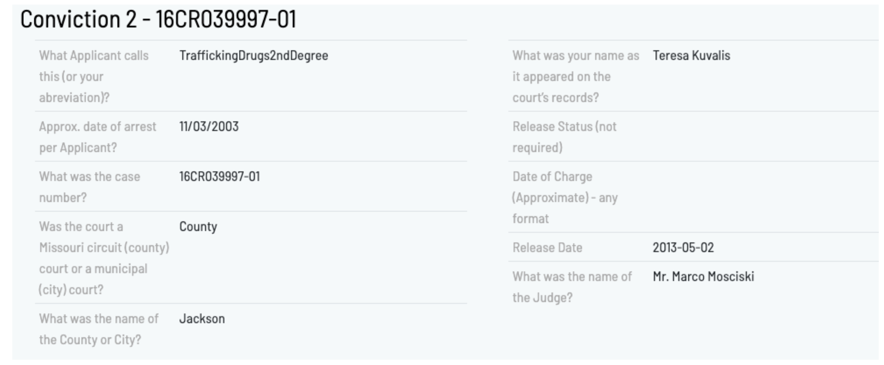

Case number

Conviction name

Date of arrest (per applicant)

Circuit (county) court or municipal (city) court? (Question: do we even need to ask this if we are requesting the circuit or municipal court name afterwards?)

Circuit or municipal court name

Applicant name as it appears in court records

Judge name

Date of charge

Release status

Release date